Atomic / Abstract Machines · Updated 3 November 2026 · atomicapp.dev
People

Meet the people behind Atomic.
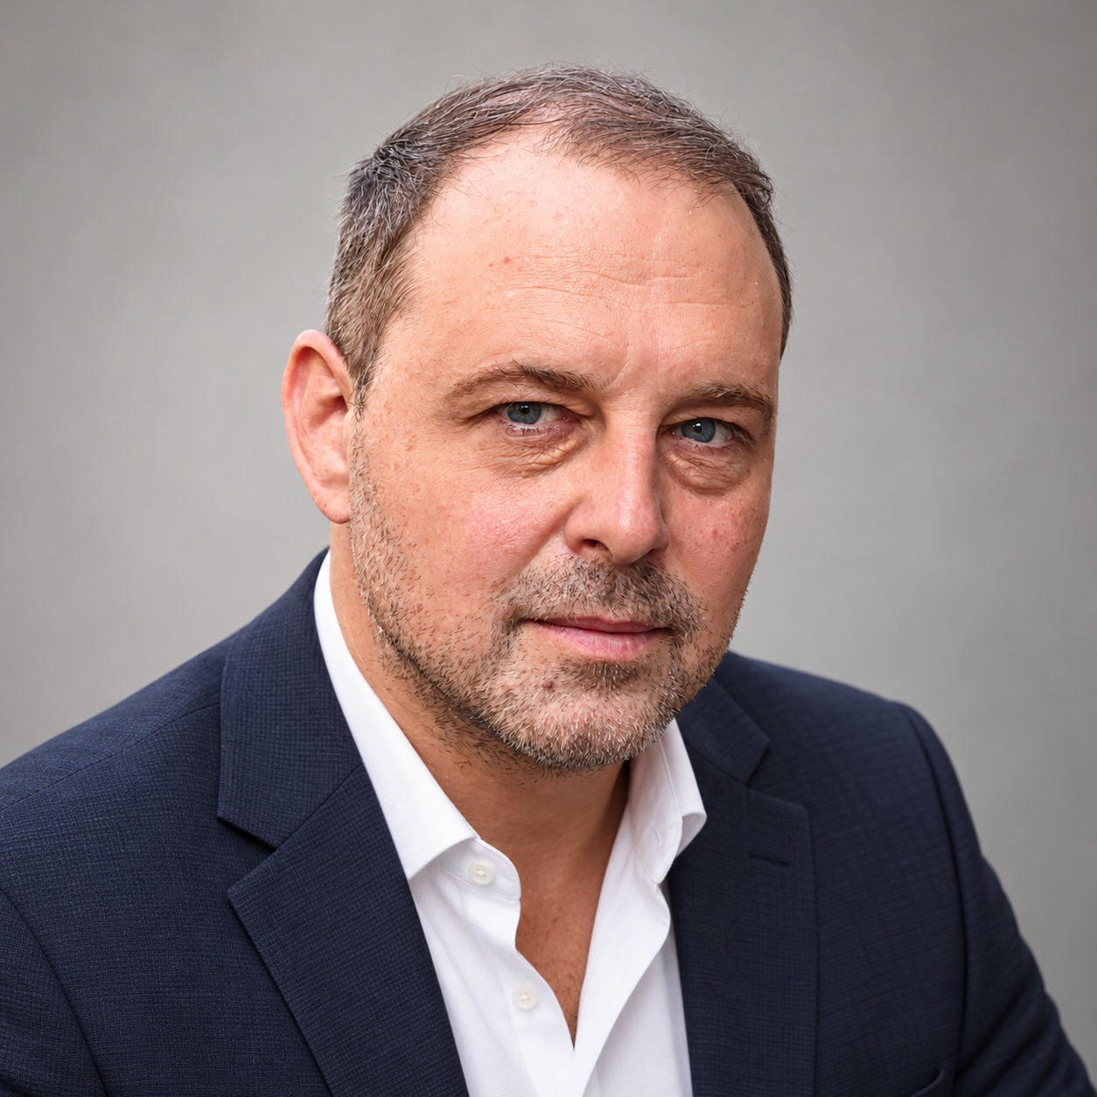
Drasko Draskovic · Founder & CEO

Drasko Draskovic
Founder & CEO · Paris, France
Drasko Draskovic is the founder of Abstract Machines and the founder and CEO behind Atomic. A deep-tech entrepreneur and systems engineer, he brings more than 20 years of experience in IoT and cloud-computing systems. His background includes work at Texas Instruments, Alcatel-Lucent, Nokia, Sequans and Devialet. He co-founded Datapace as an internal venture at Nokia, where he served as CTO. His work spans open-source infrastructure and the identity, data and execution systems that support applications. LinkedIn · X

Short bio
Drasko Draskovic is the founder of Abstract Machines and the founder and CEO behind Atomic. He is a systems engineer and entrepreneur with more than 20 years of experience in IoT and cloud computing.

Interview topics
- Taking an app from a plain-language idea through Canvas editing to a reviewed release.
- Why application identity, permissions and data matter in AI app building.
- Source visibility and open-source infrastructure.
Drasko Draskovic · Founder & CEO
drasko@absmach.eu · General enquiries: info@absmach.eu
atomicapp.dev

People

Meet the people behind Atomic.
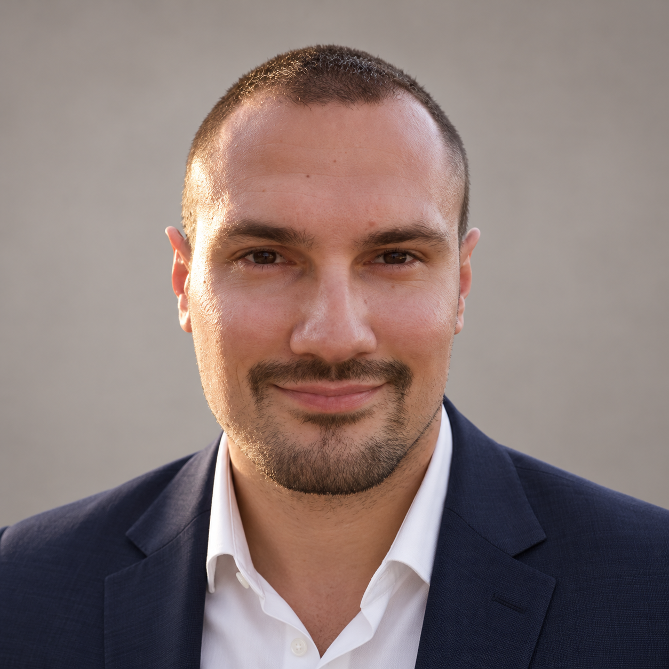

Dusan Borovcanin
Technical leadership
Dusan Borovcanin is Tech Lead at Abstract Machines, with more than 10 years of experience in distributed systems. His work includes confidential-computing infrastructure for AI and the engineering foundations behind Atomic. He previously built cocos-ai alongside Drasko Draskovic at Ultraviolet. LinkedIn · X
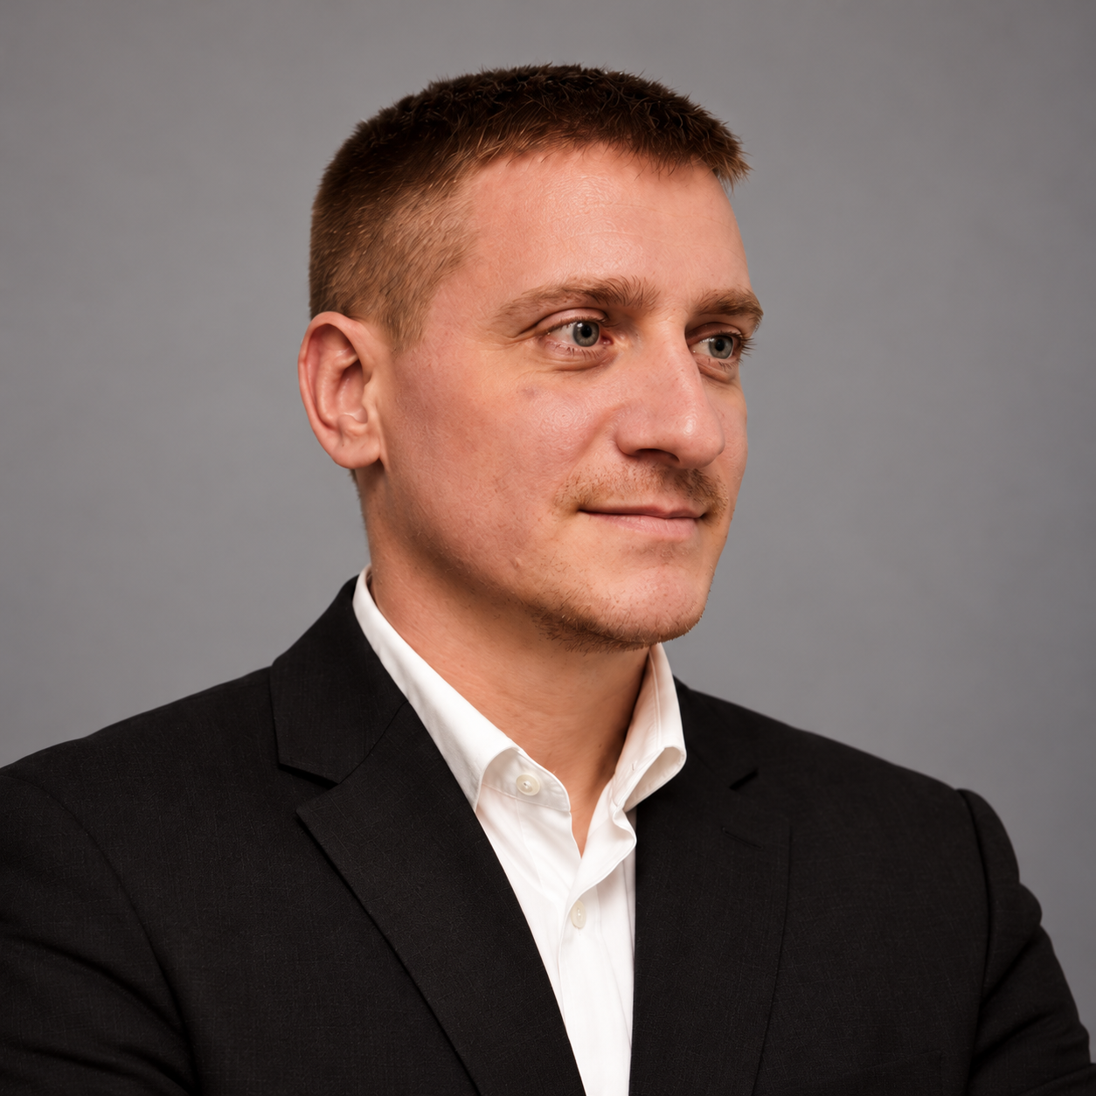

Filip Bugarski
Finance & Operations
Filip Bugarski coordinates and organizes company-wide operations at Ultraviolet, an Abstract Machines subsidiary focused on cybersecurity in Eastern Europe. He also oversees the financial operations of Abstract Machines France. LinkedIn · X
atomicapp.dev · Press room and complete media kit

