Atomic / Abstract Machines · Updated 3 November 2026 · atomicapp.dev
Video & social assets

Choose the right asset.
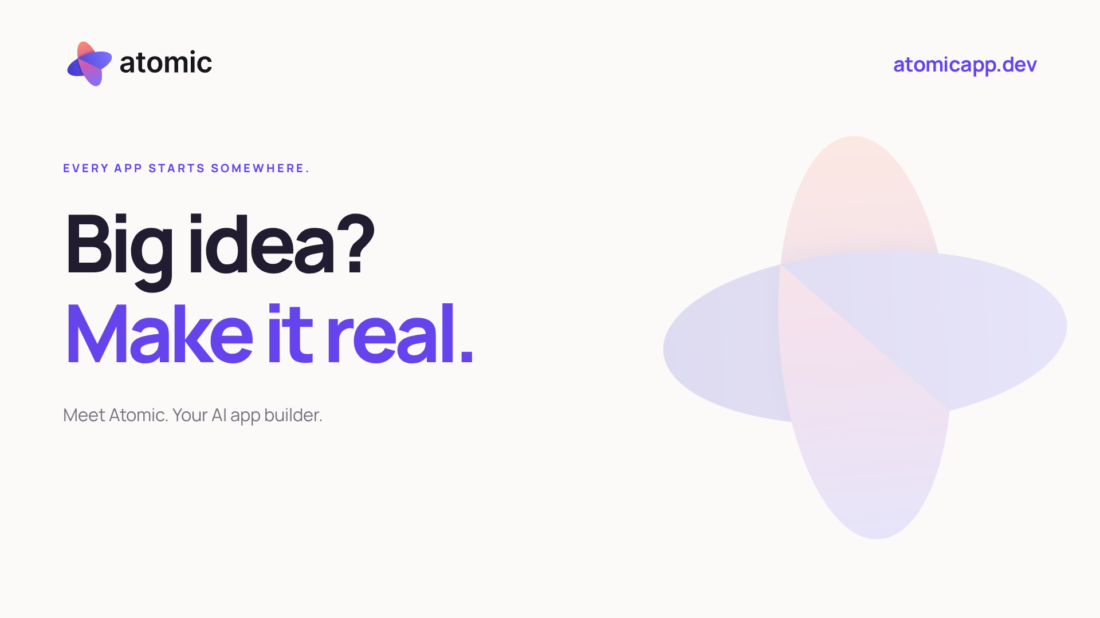
Click to watch the widescreen launch film

The 35-second launch film
All three launch formats have the same approved ElevenLabs narration, music and timing. The website appears in the opening, Canvas and closing scenes. The film carries no launch date.
YouTube / website · 16:9 | atomic-product-demo.mp4  1920 × 1080 · optional SRT/VTT captions
LinkedIn / X · 1:1 | atomic-launch-square.mp4  1080 × 1080 · built-in English captions
Instagram Reels · 9:16 | atomic-launch-vertical.mp4  1080 × 1920 · built-in English captions
MP4 · H.264 video / AAC audio · 30 fps. The square file serves both LinkedIn and X. The vertical framing follows the actual recorded Canvas controls and collaboration comment.

Video & social assets

Choose the right asset.
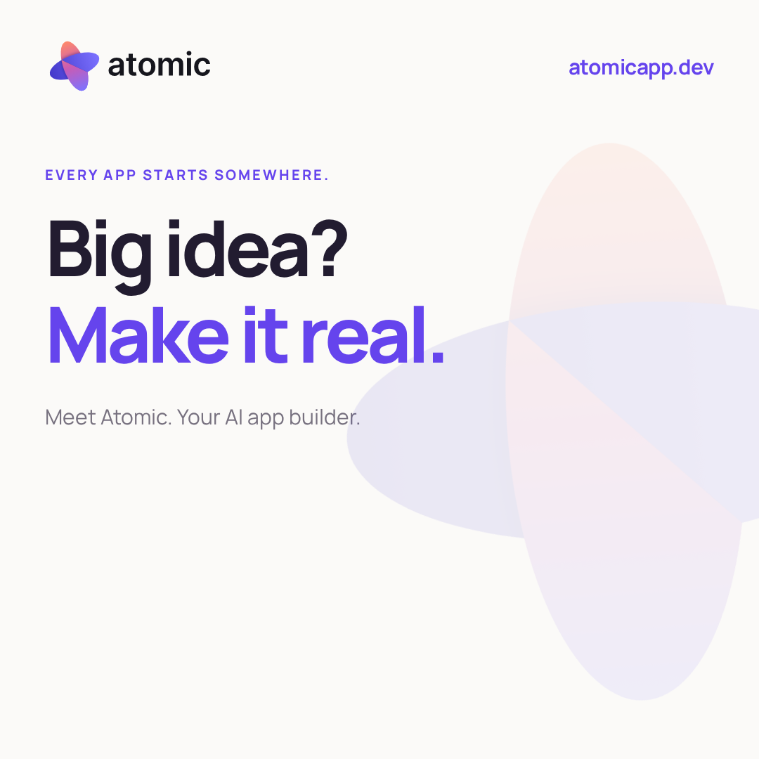  Launch cover · square · “Big idea? Make it real.” | 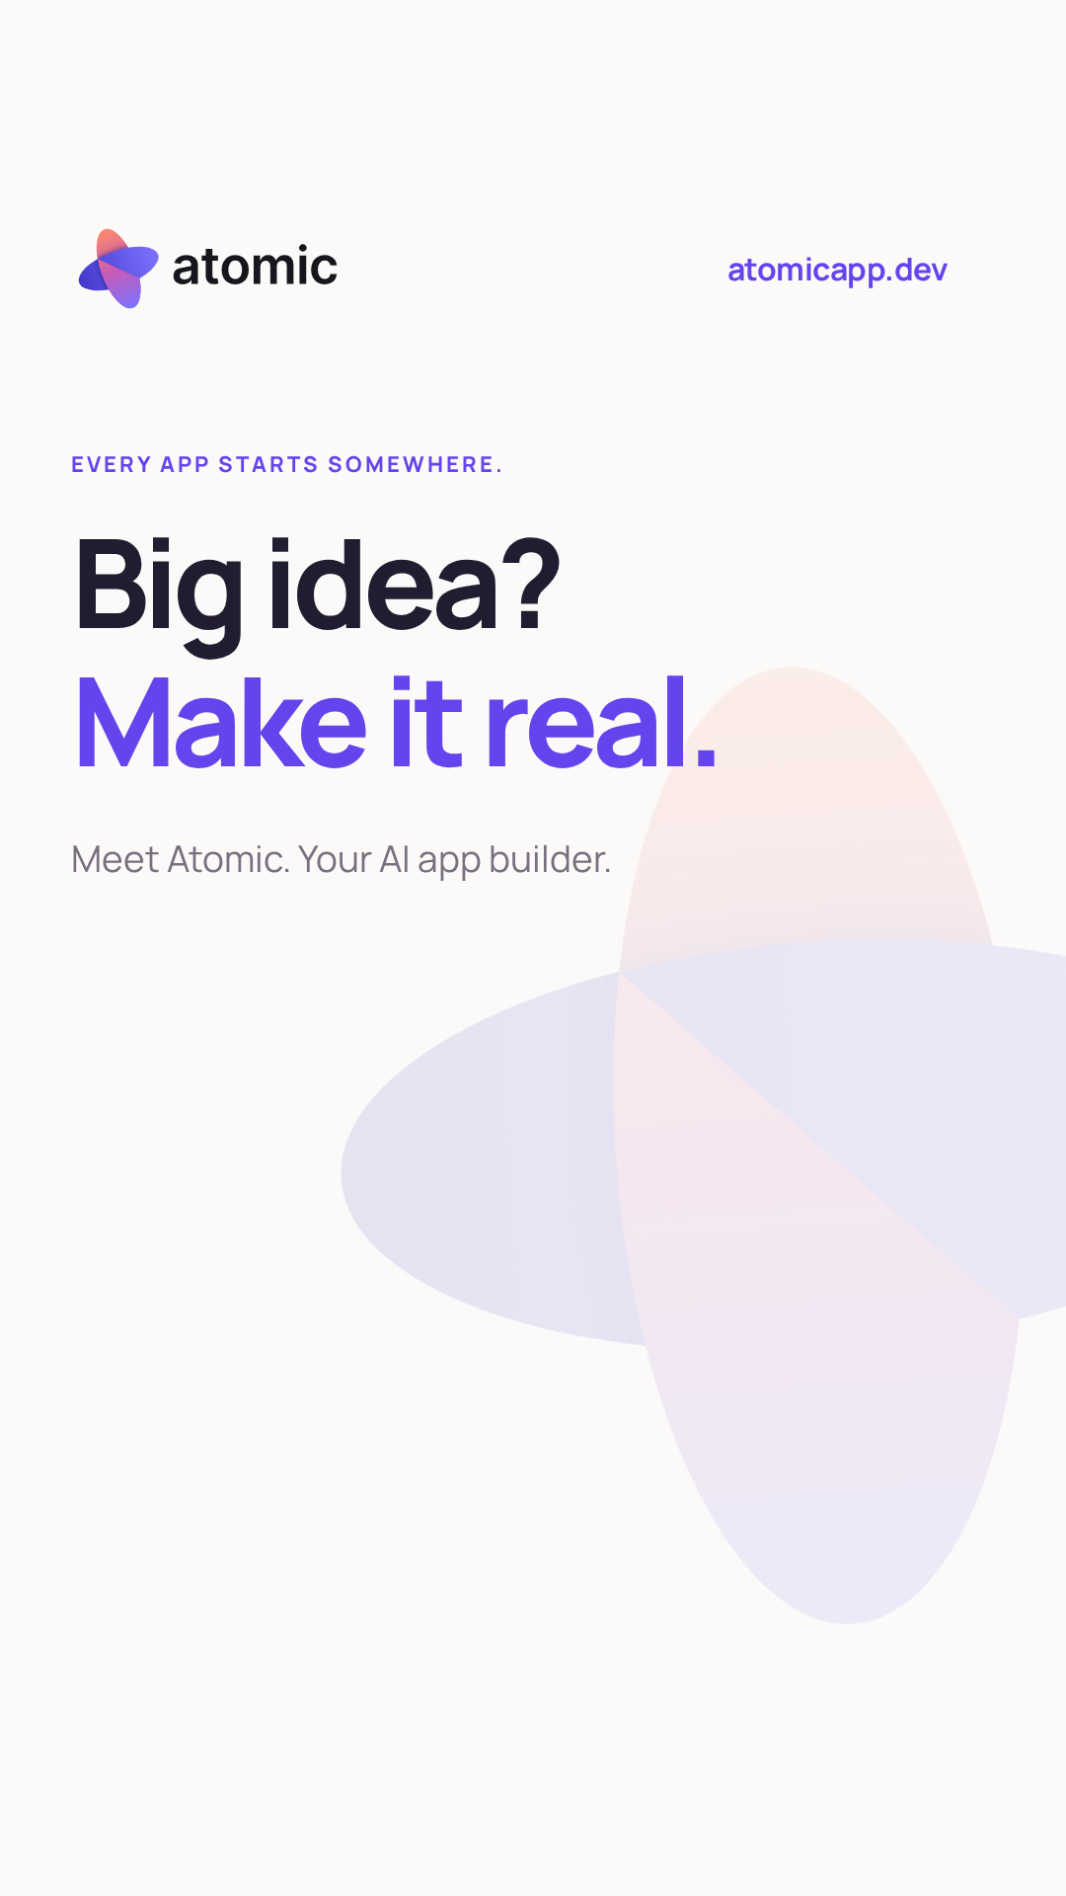  Launch cover · vertical · “Big idea? Make it real.”

Choose the matching cover
These refreshed opening designs use the new logo and website address. Choose the prepared cover when the publishing platform offers that option. The films use the current logo throughout, including the recorded app screens.

Captions and uploading
Upload the matching MP4. Square and vertical films already contain captions; avoid adding a duplicate caption layer. The product-demo SRT and VTT files share the same speech timing across all three formats. A plain-text transcript is included.

Use the current edition
The current kit supplies the three date-free launch formats and their opening-design covers. Refer to the public press room for the latest product imagery, downloadable documents and media files.

Editorial context
The footage records local sample-app interactions, with framing and a brief effect around the selected element. The standalone screenshots may show different demo states. Sample businesses and data are illustrations, not customer endorsements.
atomicapp.dev · Press room and complete media kit

